Software Design Document
Screen Capture Tool
A screenshot-to-explanation assistant powered by Anthropic API
Version 1.0
June 17, 2026
Author: Vipul Dhotre
Supervisor: Ali Naqvi
Ledelsea

Revision History
Version | Date | Author | Summary of changes
1.0 | June 17, 2026 | Vipul | Initial release. Documents the complete production design of the tool end to end, including the automatic capture loop and the actions taken on each captured frame.

Table of Contents
Revision History 2
Table of Contents 2
1. Introduction 4
1.1 Purpose 4
1.2 Scope 4
1.3 Definitions, Acronyms, and Abbreviations 4
1.4 References 5
2. System Overview 6
3. Goals and Non-Goals 6
3.1 Goals 6
3.2 Non-Goals 6
4. System Architecture 7
4.1 The five layers 7
4.2 Technology stack 8
5. Detailed Design 9
6. Data Design 12
7. Testability, Monitoring, and Operations 14
7.1 How we test 14
8. Security, Cost, and Authorization 14
8.1 Secrets 14
8.2 Screen contents 14
8.3 Cost 14
9. Delivery Roadmap 15
11. Open Questions 15

1. Introduction

1.1 Purpose
This document describes how the Screen Capture Tool is designed and how it is to be implemented. It is written for anyone who will build, review, or maintain the tool. The program itself stays small as its task is to capture the screen and forward the image to the processor. The actual reading, classifying, and explaining is done by Claude through the Anthropic API. We shape that behavior with prompts rather than with code.

1.2 Scope
This document describes the complete Screen Capture Tool — the finished production product, end to end, not a single early step. In its delivered form the tool watches the screen automatically: a global hotkey or a timed interval triggers each capture, the frame is read and explained, near-identical screens are skipped to avoid wasted work, and a running context lets every explanation build on the ones before it. A manual one-shot mode remains available for when you want to point and ask, but the headline behavior is hands-off, continuous understanding of whatever is on screen.
The tool was built riskiest-slice-first — proving that the model could explain a single screenshot before any automation was layered on — and Section 10 records that sequence. Everything else in this document, though, describes the product as a whole: its architecture, its five functional layers, the automatic capture loop and the actions it takes on each frame, the data that moves between the parts, the alternatives weighed, and how it is tested and operated. It does not cover the internals of the Anthropic API or of Claude's vision model; those are a dependency the tool calls, not a system it owns.

1.3 Definitions, Acronyms, and Abbreviations
Term | Meaning
API | Application Programming Interface
Anthropic API | The hosted service we send screenshots and prompts to, and that returns explanations.
Messages API | The specific Anthropic endpoint used to send a conversation (including images) and receive a model reply.
Claude Agent SDK | Anthropic's framework for building autonomous agent loops. We deliberately do NOT use it.
MVP | Minimum Viable Product — the smallest version that delivers the core value.
SDD | Software Design Document (this document).
Vision model | A model able to accept images as input. We use a current vision-capable Claude model.
mss | A fast Python screen-capture library used to grab pixels.
Pillow | A Python imaging library used to handle and save the captured frame.
base64 | A text encoding used to embed the screenshot image inside the API request.
.env | A local, gitignored file holding the secret API key.

1.4 References
This design was shaped by two references on how to write a useful design document, alongside the project's own requirements notes.
- Zhang, Angela. How to Write a Good Software Design Doc. freeCodeCamp / Medium, 2018. (link)
- Ackah, B., Hirji, S., & Wirtz, F. Software Design Document: Road Trip Advisor Web Application, v1.0. Bellevue College, 2018. (link)
- Screen Capture Tool — Requirements (REQUIREMENTS.md), internal project document, last updated June 16, 2026.
- Anthropic. Messages API and Python SDK documentation (docs.claude.com).

2. System Overview
At its simplest, the Screen Capture Tool is a relay system. It grabs an image of the screen, packages it up, asks Claude what the picture shows, and prints the answer. The cleverness lives in the question we ask and in the model that answers it.
Picture the flow as a short trip the image takes. A trigger — a hotkey press or a timer tick — sets a capture step photographing the screen and writing the frame to disk. That file is read back, encoded as base64 text, and placed inside a request to the Anthropic Messages API together with a carefully written prompt. The API returns text, and the tool prints it. The tool also remembers what was said about earlier screenshots and feeds that history back in, so a sequence of captures reads like a conversation rather than a set of unrelated snapshots. Because captures fire on their own, the tool also takes care to skip screens that have barely changed, so it is not paying to re-explain the same thing twice.
The whole thing is written in Python and runs from the terminal. There is no database, no message queue, no browser shell, no background service. Those are not oversights; they are choices, and Section 7 explains why we left them out. The tool leans on three small dependencies — a screen grabber, an image library, and the Anthropic SDK — plus a single secret, the API key, which lives in a local file that is never committed to source control.
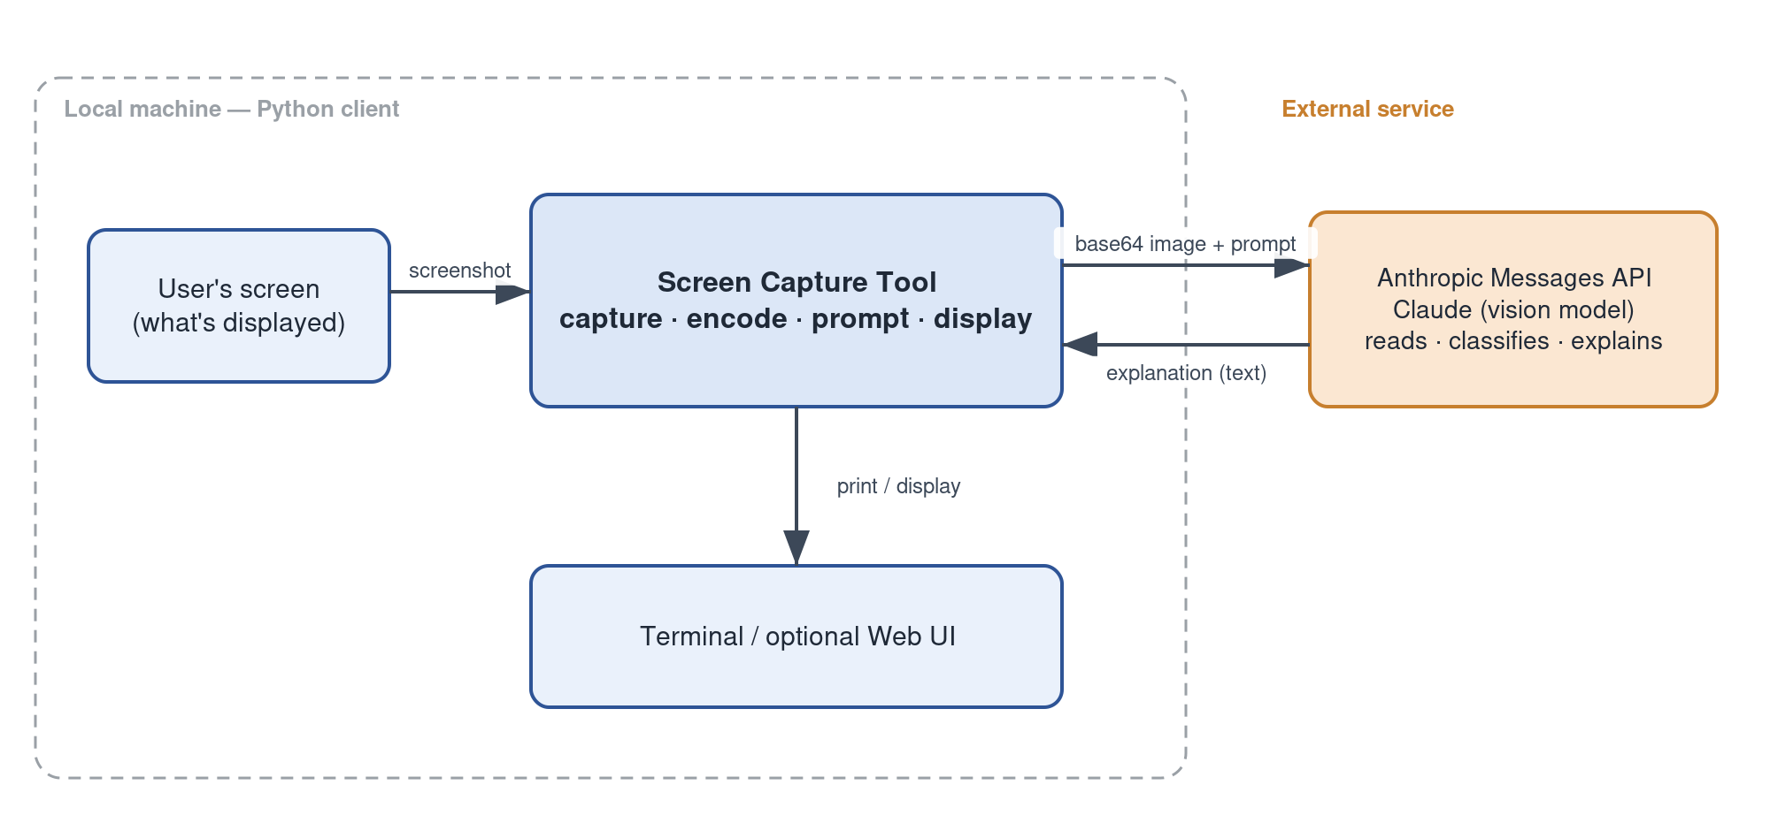
Figure 1. System context — the tool relays a screenshot to Claude and returns a plain-language explanation.

3. Goals and Non-Goals
Being explicit about what this project is not trying to do has saved more time than almost anything else, so both lists are spelled out here.

3.1 Goals
- Read a screen and explain it. Given a screenshot, return an explanation that a person would find genuinely clear and useful, whether the screen shows code, a spreadsheet, a legal document, a chart, a diagram, or ordinary prose.
- Stay thin. Keep the local program small and let Claude do the heavy lifting. Reach for a better prompt before reaching for more code.
- Prove the risky part first. Confirm early that the model can reliably read and explain real screenshots, because if it cannot, nothing else matters.
- Grow in honest increments. Each milestone should produce something that works and is worth using before the next one begins.

3.2 Non-Goals
- No heavy infrastructure in v1. No database, no queues, no microservices, no Electron desktop shell.
- No premature polish. A pretty interface is explicitly deferred until the core understanding is solid.

4. System Architecture

4.1 The five layers
The tool is organized into five layers. They are less like rigid modules and more like five jobs that have to happen, roughly in order, for a screenshot to become an explanation. Listing them this way keeps responsibilities clear and makes it obvious which layer to touch when something needs to change.
Layer | Job | How it is built
1. Understanding | Read and explain the content of the image. This is the heart of the tool and its biggest unknown. | The Anthropic API plus a well-crafted prompt. Validate this works before building anything else.
2. Capture | Grab pixels from the screen — full screen or a region — and save the frame to a file, automatically. | Python with mss and Pillow, driven by a global hotkey or a timed interval, with a manual one-shot mode available.
3. Routing | Recognize what kind of content is on screen and explain it in a way suited to that type. | Prompt engineering, not code. Claude decides the content type on the fly; no hardcoded categories.
4. State / Context | Remember earlier captures so explanations build on each other instead of starting fresh each time. | We keep the prior turns ourselves and pass them back in the API's messages array.
5. Output | Deliver the explanation to the user as captures stream in. | The terminal is the primary surface; an optional simple web page presents the same stream.

4.2 Technology stack
Concern | Choice | Why
Language | Python | Simple, quick to iterate, strong library support for both capture and the Anthropic SDK.
Screen capture | mss + Pillow | mss grabs pixels fast; Pillow handles and saves the frame so it can be encoded and sent.
Processing “brain” | Anthropic API via the anthropic Python SDK | The screenshot is base64-encoded and sent as an image block to the Messages API with a vision-capable model. We own the request and response.
Authentication | Claude Platform API key (pay-as-you-go) | Read from ANTHROPIC_API_KEY in a gitignored .env via python-dotenv. No subscription login, no Agent SDK.
Model | A current vision-capable Claude model (claude-sonnet-4-6) | Kept in one place in the code so later milestones reuse the same family.
Future UI | FastAPI + a basic web page | Only if a real interface is actually wanted, and only after the core works.

5. Detailed Design
This section walks through each layer in more depth. It follows an image through its different layers.

5.1 Understanding (Layer 1)
This is the layer the whole tool is built around, and it is mostly a prompting problem rather than a coding one. We send the model the screenshot as an image content block together with a system and user prompt that asks it to look closely and explain what is on screen in clear language. The output is text, which we print.

5.2 Capture and the Automatic Capture Loop (Layer 2)
Capture grabs pixels from the screen and writes the frame to a file on disk, which the Understanding layer then reads back and encodes. In the finished product this happens automatically: rather than asking the user to take a screenshot and run a command, the tool watches the screen on its own and feeds frames into the understanding path as they arrive. This subsection describes how that automation works and what the tool does in response to each frame.
Area modes
- Full screen — grab the entire display. The default, and the right choice when you do not know in advance where the interesting content will be.
- Region — grab a fixed rectangle you choose once. Useful for watching a single panel, log, or window without re-explaining the rest of the desktop.
Trigger modes
- Manual one-shot — capture once on demand. The simplest path, kept for point-and-ask moments.
- Hotkey — a global keyboard shortcut fires a capture from anywhere, so you can ask “what is this?” without leaving the app you are in.
- Interval — the tool captures on a timer (say, every few seconds) and keeps a running, hands-off commentary on whatever changes on screen. This is the mode that makes the tool feel automatic.
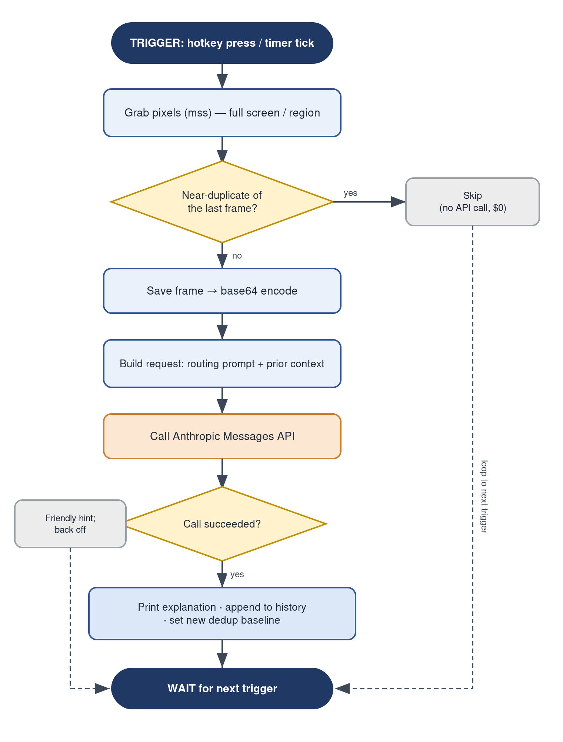
Figure 3. The automatic capture loop — from trigger to explanation, including the de-duplication skip and error back-off.

5.2.1 Actions taken on each captured frame
Each trigger leads to one of a small, predictable set of outcomes:
Trigger / condition | Action the tool takes
Capture fires (hotkey or timer) | Grab pixels in the active area mode and hold the frame in memory.
Frame is a near-duplicate of the last explained frame | Drop it silently. No file is kept, no request is sent, nothing is spent.
Frame is meaningfully new | Save it to the gitignored captures folder, base64-encode it, and build a request with the routing prompt and prior context.
Request succeeds | Print the explanation, append the turn to the running history, and remember the frame as the new baseline for de-duplication.
Content type is recognized (routing) | Tailor the explanation to that type — code, spreadsheet, chart, prose, and so on — within the same call.
API key missing or invalid | Stop with a plain-language message explaining how to fix it, rather than a raw error.
Network error or rate limit | Skip this frame, back off briefly, and continue on the next trigger.

5.3 Routing (Layer 3)
Routing answers the question “what am I looking at, and how should I explain it?” A screenshot of source code wants a different explanation than a legal contract, a spreadsheet, a chart, or a UI mockup. Crucially, this is done through prompt engineering, not through an agent framework or a hardcoded list of categories. We word the prompt so that Claude itself decides the content type on the fly and then tailors its explanation to that type.

5.4 State and Context (Layer 4)
Left to itself, each API call is in its own world— the model would explain every screenshot as if it had never seen the previous one. The State layer fixes that by keeping the prior captures and their explanations and passing them back into the Messages API in the messages array, so the conversation is genuinely multi-turn. An explanation of the third screenshot can then refer back to the first.
We manage this history ourselves rather than delegating it to any framework. Part of this layer's job is housekeeping: it works hand in hand with the capture loop's de-duplication so the tool does not waste tokens re-sending a screen that has not changed, and it stitches a sequence of captures into coherent running context.

5.5 Output (Layer 5)
Output is the least glamorous layer and that is on purpose. The primary surface is the terminal, where explanations stream in as captures arrive — in interval mode this reads like a live commentary on the screen. An optional graphical interface, a small FastAPI service serving a basic web page, presents that same stream for anyone who would rather not watch a terminal. The interface deliberately adds no intelligence of its own; it is a window onto the explanations the rest of the tool produces. A final and cleaner output layer will be implanted once all other milestones are completed.

6. Data Design
What is the data? How will it be handled?
Data item | Form | Lifetime and handling
Screenshot frame | Image file on disk (e.g. PNG) | Written to a gitignored captures folder; treated as scratch and safe to delete.
Encoded image | base64 text inside the API request | Created in memory at send time; not persisted separately.
Prompt | System and user text | Lives in the code; the main lever for tuning behavior.
Conversation history | An in-memory messages array | Holds prior captures and explanations for the session; passed back to the API for multi-turn context.
Previous-frame baseline | The last explained frame, held in memory | Compared against each new capture so near-identical screens are skipped before any request is built.
Explanation | Text returned by the API | Printed to the user and appended to the conversation history.
API key | Secret string in .env | Loaded via python-dotenv into an environment variable; .env is gitignored and must never be committed.
The most sensitive item by far is the API key, and the rule around it is simple and absolute: it lives only in the local .env file, that file is listed in .gitignore, and it never enters source control. The code reads it from the environment at startup and fails with a clear, helpful message if it is missing.
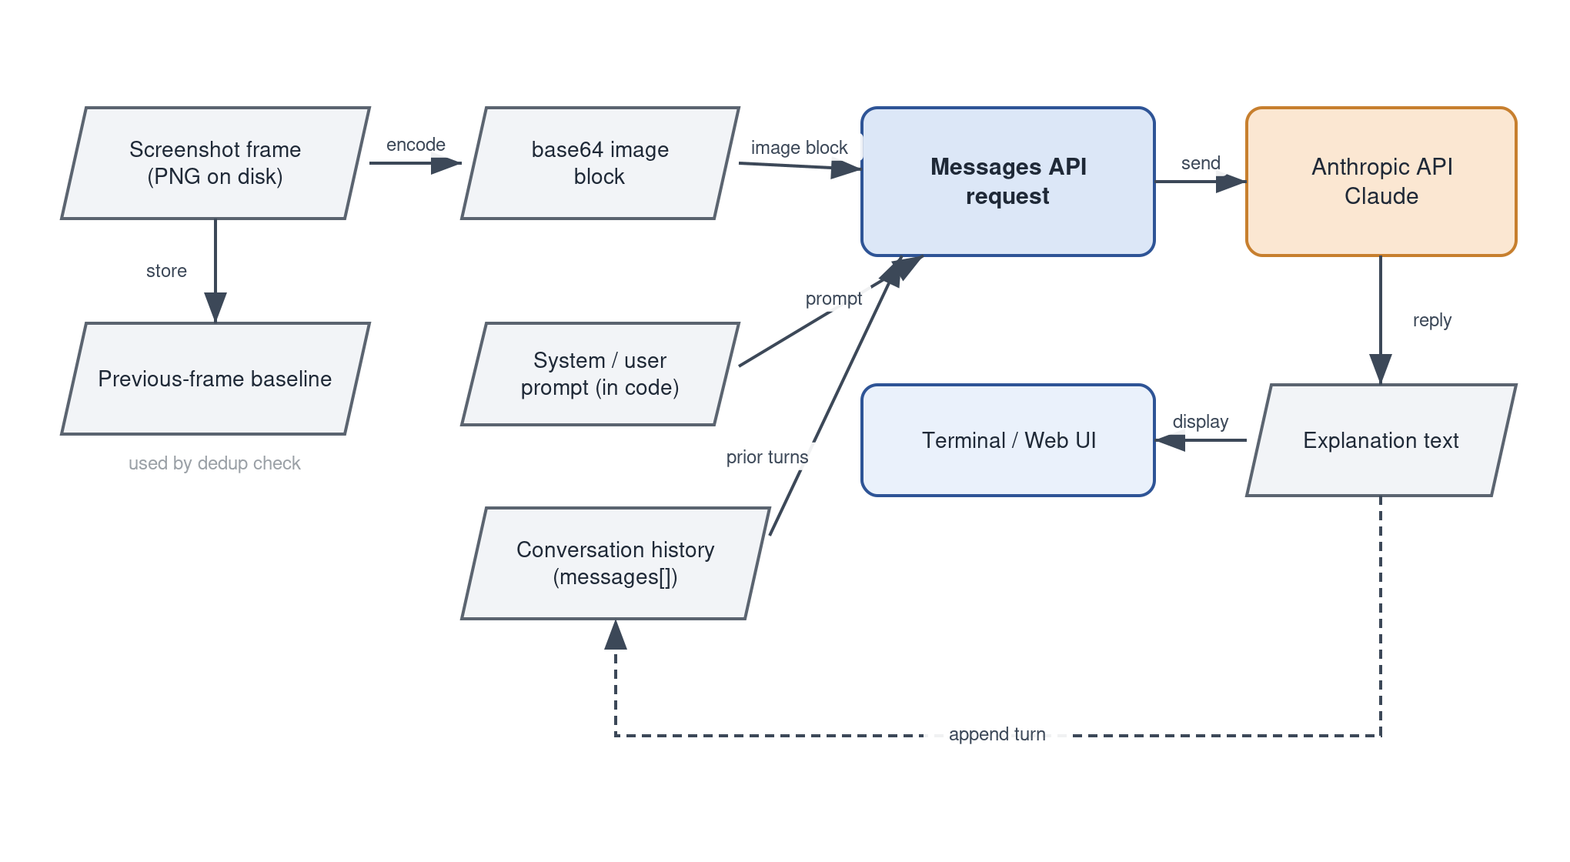
Figure 4. Data flow — the items that move through the tool on each capture, and the feedback into conversation history.

7. Testability, Monitoring, and Operations
The tool's correctness is unusual in that the hardest thing to test is also the most important: whether an explanation is actually useful for the client.

7.1 How we test
- Connectivity check. A small script (hello_api.py) confirms the package is installed, the key is present, and a round-trip to the Messages API returns text. This is the foundation and it already passes.
- Golden screenshots. A small set of varied, real screenshots — code, a spreadsheet, a chart, prose, a UI — run through the tool, with explanations reviewed by hand for quality. This is the primary measure of whether Understanding works.
- Prompt regression. When a prompt changes, the golden screenshots are re-run to make sure explanations got better and not quietly worse.
- Failure-path checks. Confirm the tool fails gracefully and says something useful when the key is missing, the package is absent, or the API call errors out.

8. Security, Cost, and Authorization

8.1 Secrets
The single secret is the Anthropic API key. It lives in a gitignored .env file, is loaded into the environment at runtime, and never enters source control. This is the most important security rule in the project and it is enforced by .gitignore rather than by good intentions.

8.2 Screen contents
Screenshots can contain sensitive information by their very nature. Captured frames are kept local, written to a gitignored folder, and treated as disposable scratch. Sending an image to the Anthropic API does transmit it off the machine to the model, which is inherent to how the tool works and worth being conscious of when capturing screens with private data.

8.3 Cost
Usage is pay-as-you-go, so the tool spends real money per call and per image. This is a gentle pressure toward sending fewer, better requests — another reason the context layer dedupes near-identical frames rather than re-sending the same screen.

9. Delivery Roadmap
The complete product described in this document is delivered through six phases, sequenced riskiest-slice-first so that the core understanding is proven before any automation is built on top of it. The table below is the roadmap for the whole tool, not a status report on one step: each phase contributes a clearly defined piece of the finished system. The foundation phase is already in place and validated in code; the remaining phases build out the automatic capture, routing, and context behavior detailed in Section 5.
# | Phase | What it delivers to the finished product
1 | Foundation | The project skeleton, dependencies, secret handling, and a verified round-trip to the Messages API that everything else relies on (hello_api.py).
2 | Core understanding | The screenshot-to-explanation path: a saved frame is encoded, sent with a prompt, and a clear explanation comes back.
3 | Automatic capture | Hands-off operation — a global hotkey or a timed interval drives full-screen or region capture into the understanding path with no manual steps (Section 5.2).
4 | Content routing | Open-ended content typing in the prompt, so each screen is explained in the way that suits its type.
5 | Multi-capture context | De-duplication of near-identical frames and a running, multi-turn context so explanations build on one another.
6 | Interface and polish | An optional simple web interface and the refinements that make day-to-day automatic use pleasant.
A note on sequencing discipline, since this is a solo build: phases 4 and 5 are the ones most likely to invite over-engineering. Each starts with a single well-crafted prompt and a plain history, with cleverness added only where the simple version visibly falls short.

11. Open Questions
A few things are undecided, and here are a few of them:
- How reliable is open-ended content typing across the messy range of real screens, and where exactly is the line at which we switch to the predefined-category fallback?
- What is the right amount of conversation history to keep before context becomes noisy or expensive, and how aggressively should near-identical frames be deduped?
- When the time comes, which implantation will be used for the front-end user?

